Costar 7.0 User's Manual

Software Cost Estimation Program

Copyright © 1986-2003 Softstar Systems. All rights reserved.

Costar™ and Calico™ are trademarks of Softstar Systems.
Ada™ is a trademark of the Department of Defense.

http://www.SoftstarSystems.com
sales@SoftstarSystems.com
support@SoftstarSystems.com

Phone: (603) 672-0987
FAX: (603) 672-3460

Softstar Systems
P.O. Box 1360
Amherst, NH 03031

Table of Contents

1. Installing Costar 1
1.1 System Requirements 1
1.2 Before You Start 1
1.3 Installing the Software 1
1.4 Running Costar 2

2. Introduction to Costar 3
2.1 The COCOMO Model 3
2.2 Extensions to COCOMO 3
2.3 Costar Concepts 4
2.4 Component Editing 5
2.5 The Current Component 6
2.6 Inherited Attributes 6
2.7 Dealing with More Than One Estimate 7

3. Introduction to COCOMO 9
3.1 Introduction 9
3.2 Source Lines of Code (SLOC) 9
3.3 Scale Drivers 9
3.4 Cost Drivers 9
  - The Post-Architecture Model 10
  - The Early Design Model 10
3.7 COCOMO II Effort Equation 10
3.8 Effort Adjustment Factor 10
3.9 COCOMO II Schedule Equation 12
3.10 The SCED Cost Driver 12
3.11 Ada COCOMO 14
3.12 Incremental Development COCOMO 14
3.13 Function Points 14
3.14 Sizing & Reuse 14

4. COCOMO Models 15
4.1 Costar's Built-in Models 15
4.2 Creating your own Models 15

5. Learning about Costar & COCOMO 17
5.1 Online Help 17
5.2 Costar Readme File 17
5.3 COCOMO Books 17
5.4 COCOMO II Model Definition Manual 17
5.5 Ada COCOMO & Incremental COCOMO 17
5.6 Softstar Systems Website 17
5.7 Support 17
5.8 Training 17
5.9 Costar Version Information 18

1. Installing Costar
Costar 7.0 supports the latest COCOMO II estimating and sizing models, as well as the COCOMO 81, Ada COCOMO, Incremental COCOMO, and REVIC models.

Installation of Costar takes less than 5 minutes. No DLLs are required or installed by Costar.

1.1 System Requirements
In order to run Costar, you'll need:
- Windows 95, Windows 98, Windows NT 4, Windows 2000, or Windows XP.
- 4MB free space on your hard disk.
- 128MB of physical memory.
- A mouse or compatible pointing device.

1.2 Before You Start
The standard Windows precaution is a good idea: you should save your work, and exit from all of your applications before starting the installation.

1.3 Installing the Software
Costar is delivered in a compressed format on a CD. You'll run the setup program to uncompress and install the Costar executable and related files.

Follow these instructions to install Costar:
- Insert the Costar CD into the CD drive. The setup program will start automatically.
- Choose Next to acknowledge the introductory screen, and continue with the installation.
- The Destination Folder identifies the disk directory where Costar's files will be installed. All of Costar's files will be installed in \Program Files\Softstar\Costar 7 by default.
To change the Destination Folder, click Browse. A dialog box will be opened so that you can select an alternate installation directory. After selecting an alternate destination directory, choose OK to close the dialog box.
To accept the Destination Folder, click Next.
- The default Program Folder name is Costar 7.0.
This name is used to create a folder on the Start | Program menu.
To accept the default Program Folder name, click Next. Otherwise change the name, and then click Next.
- After all of the Costar files are uncompressed and installed, you are offered the chance to review the readme.txt file. The readme.txt file has important information that you should read before running Costar.
- Choose Finish to exit from the setup program.

1.4 Running Costar
Here are three ways to run Costar:
- Double-click the Costar 7.0 icon installed on the desktop.
- Select Costar 7.0 from the Costar 7.0 folder on the Windows Start Menu.
- Double-click a Costar cost estimate icon on your desktop.

2. Introduction to Costar
Costar is a software cost estimation tool based on the Constructive Cost Model (COCOMO) described by Dr. Barry Boehm in his books Software Engineering Economics (Prentice-Hall, 1981) and Software Cost Estimation with COCOMO II (Prentice Hall, 2000). Software project managers use Costar to produce estimates of a project's duration, staffing levels, and cost. Costar lets you make trade-offs and experiment with "what-if" analyses to arrive at a satisfactory project plan.

Costar 7.0 supports the latest COCOMO II estimating and sizing models, as well as the COCOMO 81, Ada COCOMO, Incremental COCOMO, and REVIC models.

2.1 The COCOMO Model
The COCOMO cost estimation model is used by thousands of software project managers, and is based upon a study of hundreds of software projects. Unlike other cost estimation models, COCOMO is an open model, so all of the details are published, including:
- The underlying cost estimation equations
- Every assumption made in the model (e.g. "the project will enjoy good management")
- Every definition (e.g. the precise definition of the Product Design phase of a project)
- The costs that COCOMO estimates are stated (e.g. project managers are included, secretaries aren't)

Because COCOMO is well defined, and because it doesn't rely upon proprietary estimation algorithms, Costar offers these advantages to its users:
- COCOMO estimates are more objective and repeatable than estimates made by methods relying on proprietary models
- COCOMO can be calibrated to reflect your software development environment, and to produce more accurate estimates

Costar is a faithful implementation of COCOMO II. It's easy to use on small projects, and yet powerful enough to plan and control large projects.

Caution: It is so easy to use Costar to make software cost estimates, that it's possible to misuse it – every Costar user should spend the time to learn the underlying COCOMO assumptions and definitions from Software Engineering Economics and Software Estimation with COCOMO II. In addition to defining COCOMO, the books contain a wealth of material about other aspects of project management and cost estimation. The rest of this manual assumes that you have a working knowledge of COCOMO II.

2.2 Extensions to COCOMO
The original COCOMO defines a three level hierarchy to describe the structure of a software system under development (the three levels are system, subsystem, and module). The hierarchy is defined to contain only three levels to simplify the necessary calculations so that they can be done by hand. Costar relaxes this constraint, so that a software system consisting of any number of different levels can be described.

For similar reasons, COCOMO 81 constrains you so that certain cost drivers can only be defined for certain levels in the hierarchy. For example, the Analyst Capability cost driver is assigned at the subsystem level, but the Programmer Capability is assigned at the module level. Costar relaxes this constraint so that you have more flexibility.

The original COCOMO 81 model estimated duration for the Programming phase (PG), but not for its two constituents Detailed Design and Code & Unit Test. Costar calculates the duration of the Detailed Design and Code & Unit Test phases separately.

Costar extends Incremental Development COCOMO beyond the published definition by applying it to a full hierarchy of components and subcomponents, rather than just a single component per increment. Costar also applies Incremental Development to COCOMO II and REVIC.

2.3 Costar Concepts
When you run Costar, the Create Estimate Wizard is launched to help you create your first estimate. Just click Next to advance through the steps of the wizard -- the wizard will offer explanations and advice on how to set the COCOMO parameters. Figure 1 depicts the wizard.
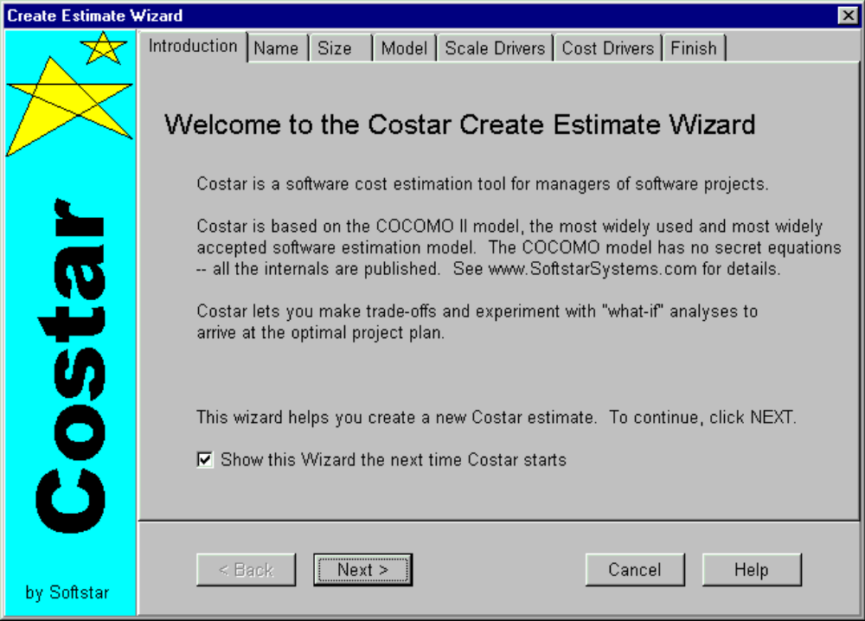Figure 1 -- The Create Estimate Wizard

After the wizard is complete, Costar displays its main window (see Figure 2). The main window lets you modify any of the parameters and settings that pertain to your estimate.

One estimate is always distinguished as the current estimate. All of the information describing the current estimate is displayed on the main window. You control which estimate is the current estimate. You can select a certain estimate to be the current estimate with the File | View Estimate List dialog box.

Initially, your estimate consists of a single component. You may create subcomponents by using Components | Create Subcomponent. An estimate may consist of many components, but only one at a time is displayed in the main window.

The Costar window has three toolbars with buttons for some of the most common operations:
- The Estimate Toolbar
- The Component Toolbar
- The Reports Toolbar

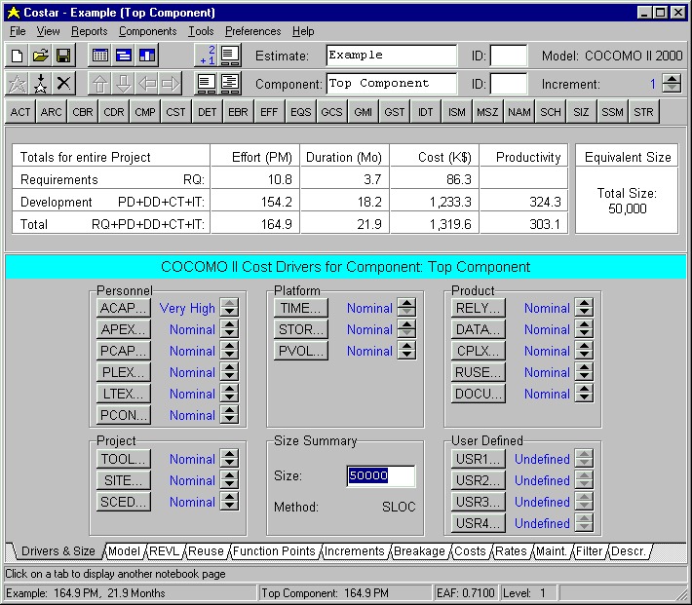
Figure 2 -- The Costar Window

Costar normally updates its estimates immediately, as you enter commands, modify cost drivers, and make other changes to your project's description. A brief summary of the estimate is normally displayed in the Automatic Estimation Panel of the Costar Window. You can turn this feature on or off by using a button on the Estimate Toolbar.

2.4 Component Editing
Most of your interactions with Costar will involve creating and modifying components. You'll define subcomponents, assign cost driver values, estimate the size of each component, etc.

2.5 The Current Component
One component is always distinguished as the current component. The name of the current component is displayed in the Component Toolbar, and the cost driver settings you've assigned to it, and other attributes of the current component are displayed in the tabbed notebook of the main window.

You control which component is the current component. You can instruct Costar to make a certain component the current component by:
- Using View | Component List from the main window
- Using View | Component Tree from the main window
- Using the Display Component List button on the Component Toolbar
- Using the Display Component Tree button on the Component Toolbar
- Using the Up, Down, Prev, and Next buttons on the Component Toolbar to navigate to the parent component, a subcomponent, or to sibling components.

Costar allows you to define a software structure to meet your needs. Typically, you'll start with only a rough idea about the software system that you'll be developing, and you'll use Costar to give you early estimates about the proper schedule and staffing levels. As you refine your knowledge of the problem, and as you design more of the system, you can use Costar to produce more and more refined estimates.

Your initial estimate might be made on the basis of a "system" containing 8,000 lines of code. Your second estimate might be more refined so that you now understand that your system will consist of two subsystems (and you'll have a more accurate idea about how many lines of code will be in each of the subsystems). Your next estimate will continue the process – you can use Costar to define the components of each subsystem. Costar permits you to continue this process until you arrive at the level of detail that suits your needs.

You can assign different values for the cost drivers for each component. For example, you might adjust the Programmer Capability setting for a given component as you learn more about the personnel available to you, or as you experiment with different work assignments to produce the shortest schedule estimates.

Costar can produce a variety of reports – some offer an overall estimate of the project's schedule and staffing levels, but others describe individual components.

2.6 Inherited Attributes
As described above, a given component may be made up of any number of subcomponents. When you create a new subcomponent (by pressing the New Subcomponent button on the Component Toolbar), the new component becomes a subcomponent of the current component and it becomes the new current component. The new component inherits values for each of its attributes from its parent component. The following attributes are inherited:
- Settings for the Development Cost Drivers
- Settings for the Maintenance Cost Drivers
- Cost per Person-Month settings
- Maintenance, Adaptation, and Conversion settings

For example, if the current component is named "Commands", and "Commands" has a rating of Very High for the CPLX (complexity) cost driver, pressing the New Subcomponent button will create a new component named "Component1" that also has a rating of Very High for CPLX. "Component1" (the new current component) inherited the value from "Commands", its parent.

The top-level component inherits its default values from the model. Normally these are preset to "nominal" ratings, but you can modify these defaults to customize the model to your needs (perhaps all of your applications are rated Very High for complexity). See the Calico documentation for more information about customizing the model.

2.7 Dealing with More Than One Estimate
To facilitate your project planning, Costar makes it easy to perform "what-if" analyses, and to compare different project plans. You may develop a new estimate based upon an older one, and then use Costar reports to compare the two.

There are several ways to create an estimate:
- File | New Estimate creates a new estimate
- File | Copy Estimate duplicates the current estimate (with a new name)
- Tools | Create Estimate Wizard will launch the wizard to create a new estimate

Costar defines an estimate to consist of:
- A name
- An ID of up to 4 characters
- A one line description
- An associated model (e.g. COCOMO_II)
- Names of labor classes (e.g. Programmer)
- Costs of labor classes (e.g. $8000 per Person-Month)
- One or more components
- The 5 COCOMO II Scale Factors

3. Introduction to COCOMO

3.1 Introduction
This section outlines the most fundamental calculation in the COCOMO model – the use of the Effort Equation to estimate the number of Person-Months required to develop a project. Most of the other COCOMO results, including the estimates for duration, requirements, and maintenance, are derived from this quantity.

To use COCOMO to your best advantage, you should understand the assumptions and definitions behind the model. Software Engineering Economics and Software Cost Estimation with COCOMO II describe the model in detail, and indicate how the model was developed and validated.

3.2 Source Lines of Code (SLOC)
The COCOMO calculations are based on your estimate of a project's size, measured in Source Lines of Code (SLOC).

The COCOMO II Model Definition Manual defines SLOC using checklists adapted from the Software Engineering Institute. Tools are available that examine source files and count SLOC, using the COCOMO II definitions.

A Source Line of Code (SLOC) is defined such that:
- Only Source lines that are delivered as part of the product are included – test drivers and other support software is excluded
- Source lines are created by the project staff – code generated by applications generators is excluded
- One line of code is one logical statement
- Declarations are counted as lines of code
- Comments are not counted as lines of code

The original COCOMO 81 model was defined in terms of Delivered Source Instructions, which are very similar to SLOC. The more recent COCOMO II model is defined in terms of SLOC. The major difference between DSI and SLOC is that a single logical Source Line of Code may be several physical lines. For example, an "if-then-else" statement would be counted as one SLOC, but might be counted as several DSI.

3.3 Scale Drivers
The five COCOMO II Scale Drivers determine the exponent used in the Effort Equation:
- Precedentedness
- Development Flexibility
- Architecture / Risk Resolution
- Team Cohesion
- Process Maturity

The Scale Drivers replace the COCOMO 81 Development Mode (Organic, Semidetached, or Embedded). This change isn't a radical departure from the traditional COCOMO model. The first two Scale Drivers, Precedentedness and Development Flexibility actually describe much the same influences that the original Development Mode did.

The other three Scale Drivers are refinements of the Ada Process Model parameters.

3.4 Cost Drivers
COCOMO II has 17 cost drivers – you assess your project, development environment, and team to set each cost driver. The cost drivers are multiplicative factors that determine the effort required to complete your software project. For example, if your project will develop software that controls an airplane's flight, you would set the Required Software Reliability (RELY) cost driver to Very High. That rating corresponds to an effort multiplier of 1.26, meaning that your project will require 26% more effort than a typical software project.
 |  | COCOMO II  Post  Architecture | COCOMO II  Early  Design | REVIC | COCOMO 87,  ADA 87,  APM 88 | COCOMO 81,  COCOMO 85
 | Personnel Factors
ACAP | Analyst Capability | Yes |  | Yes | Yes | Yes
APEX AEXP | Applications Experience | Yes |  | Yes | Yes | Yes
PCAP | Programmer Capability | Yes |  | Yes | Yes | Yes
LEXP | Programming Language Experience |  |  | Yes | Yes | Yes
VEXP | Virtual Machine Experience |  |  | Yes | Yes | Yes
PERS | Personnel Capability |  | Yes
PREX | Personnel Experience |  | Yes
PCON | Personnel Continuity | Yes
PLEX PEXP | Platform Experience | Yes
LTEX | Language and Tool Experience | Yes
 | Product Factors
RELY | Required Software Reliability | Yes |  | Yes | Yes | Yes
DATA | Database Size | Yes |  | Yes | Yes | Yes
CPLX | Software Product Complexity | Yes |  | Yes | Yes | Yes
RUSE | Required Reusability | Yes | Yes | Yes | Yes
DOCU | Documentation Match to Life-Cycle Needs | Yes
RCPX | Product Reliability and Complexity |  | Yes
 | Platform factors
TIME | Execution Time Constraint | Yes |  | Yes | Yes | Yes
STOR | Main Storage Constraint | Yes |  | Yes | Yes | Yes
TURN | Computer Turnaround Time |  |  | Yes | Yes | Yes
VIRT | Virtual Machine Volatility |  |  | Yes |  | Yes
VMVH | Virtual Machine Volatility: Host |  |  |  | Yes
VMVT | Virtual Machine Volatility: Target |  |  |  | Yes
PVOL | Platform Volatility | Yes
PDIF | Platform Difficulty |  | Yes
PLAT | Platform |  |  | Yes
 | Project Factors
TOOL | Use of Software Tools | Yes |  | Yes | Yes | Yes
MODP | Use of Modern Programming Practices |  |  | Yes | Yes | Yes
SCED | Required Development Schedule | Yes | Yes | Yes | Yes | Yes
SECU | Classified Security Application |  |  | Yes | Yes
SITE | Multisite Development | Yes
FCIL | Facilities |  | Yes
RVOL | Requirements Volatility |  |  | Yes
Figure 3 -- Costar Cost Drivers
Each Costar model implements a different set of Cost Drivers and Equations (see Figure 3).

COCOMO II defines each of the cost drivers, and the Effort Multiplier associated with each rating. Check the Costar help for details about the definitions and how to set the cost drivers.

3.5 The Post-Architecture Model
The COCOMO II Post-Architecture model, based on 17 cost drivers, is the most commonly used form of COCOMO II. If you don't know enough about your project to set the 17 cost drivers (i.e. it's too early in the development process to know all of the details), you can use the Early Design model instead of the Post Architecture model.

3.6 The Early Design Model
COCOMO II includes an Early Design model, simplified to use only seven cost drivers. This model is suitable for early estimates, before all of the details of the project's staffing and architecture are resolved.

Each of the Early Design cost drivers corresponds to several Post-Architecture cost drivers.

It uses the same equations and Scale Factors as the more complete Post-Architecture model.

3.7 COCOMO II Effort Equation
The COCOMO II model makes its estimates of required effort (measured in Person-Months – PM) based primarily on your estimate of the software project's size (as measured in thousands of SLOC, KSLOC)):

Effort = 2.94 * EAF * (KSLOC)^{E}

Where
EAF Is the Effort Adjustment Factor derived from the Cost Drivers
E Is an exponent derived from the five Scale Drivers

As an example, a project with all Nominal Cost Drivers and Scale drivers would have an EAF of 1.00 and exponent, E, of 1.0997. Assuming that the project is projected to consist of 8,000 source lines of code, COCOMO II estimates that 28.9 Person-Months of effort is required to complete it:

Effort = 2.94 * (1.0) * (8)^{1.0997} = 28.9 Person-Months

3.8 Effort Adjustment Factor
The Effort Adjustment Factor in the effort equation is simply the product of the effort multipliers corresponding to each of the cost drivers for your project.

For example, if your project is rated Very High for Complexity (effort multiplier of 1.34), and Low for Language & Tools Experience (effort multiplier of 1.09), and all of the other cost drivers are rated to be Nominal (effort multiplier of 1.00), the EAF is the product of 1.34 and 1.09.

Effort Adjustment Factor = EAF = 1.34 * 1.09 = 1.46

Effort = 2.94 * (1.46) * (8)^{1.0997} = 42.3 Person-Months

3.9 COCOMO II Schedule Equation
The COCOMO II schedule equation predicts the number of months required to complete your software project. The duration of a project is based on the effort predicted by the effort equation:

Duration = 3.67 * (Effort)^{SE}

Where
Effort Is the effort from the COCOMO II effort equation
SE Is the schedule equation exponent derived from the five Scale Drivers

Continuing the example, and substituting the exponent of 0.3179 that is calculated from the scale drivers, yields an estimate of just over a year, and an average staffing of between 3 and 4 people:

Duration = 3.67 * (42.3)^{0.3179} = 12.1 months

Average staffing = (42.3 Person-Months) / (12.1 Months) = 3.5 people

Figure 4 shows these results in the Costar Detail report.

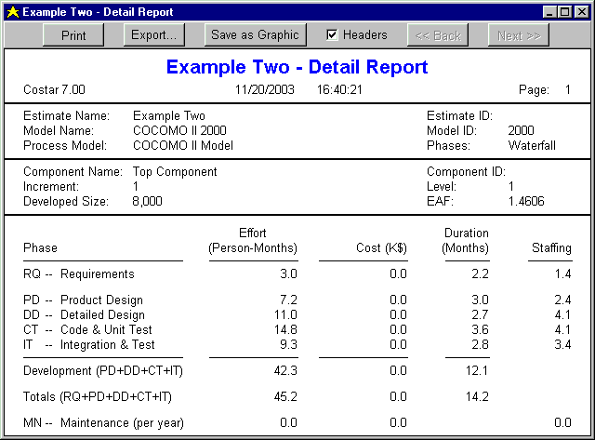
Figure 4 -- Costar's Detail Report

3.10 The SCED Cost Driver
The COCOMO cost driver for Required Development Schedule (SCED) is unique, and requires a special explanation.

The SCED cost driver is used to account for the observation that a project developed on an accelerated schedule will require more effort than a project developed on its optimum schedule. A SCED rating of Very Low corresponds to an Effort Multiplier of 1.43 (in the COCOMO II.2000 model) and means that you intend to finish your project in 75% of the optimum schedule (as determined by a previous COCOMO estimate). Continuing the example used earlier, but assuming that SCED has a rating of Very Low, COCOMO produces these estimates:

Duration = 75% * 12.1 Months = 9.1 Months

Effort Adjustment Factor = EAF = 1.34 * 1.09 * 1.43 = 2.09

Effort = 2.94 * (2.09) * (8)^{1.0997} = 60.4 Person-Months

Average staffing = (60.4 Person-Months) / (9.1 Months) = 6.7 people

Notice that the calculation of duration isn't based directly on the effort (number of Person-Months) – instead it's based on the schedule that would have been required for the project assuming it had been developed on the nominal schedule. Remember that the SCED cost driver means "accelerated from the nominal schedule".

Constraints | Constrain Project displays a dialog box that lets you trade off duration vs. effort (SCED is set for you automatically). In the example, the schedule has been constrained to 10.0 months (between the SCED Low and Very Low settings), increasing the effort by 19.8%. Figure 5 shows an example of the Constrain Project dialog box.

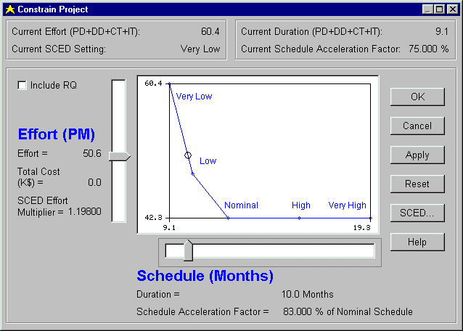
Figure 5 -- The Constrain Project dialog box

3.11 Ada COCOMO
The document TRW IOC Ada COCOMO: Definitions and Refinements (Barry Boehm & Walker Royce, 1987 & 1988) and the document Recent Developments in Ada COCOMO (Barry Boehm, 1989) define Ada COCOMO and Incremental COCOMO.

Two new cost drivers, SECU (Classified Security Application) and RUSE (Required Reusability) have been added to these COCOMO models. You can check the Costar help messages for definitions.

The model named ADA_87 assumes that the Ada programming language is being used. Use of Ada makes it easier to develop highly reliable systems and to manage complex applications, so the cost drivers RELY and CPLX have new definitions.

The APM_88 model is based upon a process model called the Ada Process Model. Among the assumptions are:
- You use Ada to produce compiler checked package specifications by the Product Design Review (PDR)
- Small design teams are used
- More effort is spent in requirements analysis and design
- Less effort is spent in coding, integration, and testing

The APM_88 model incorporates changes to the equations, several cost drivers, and a variety of other tables.

3.12 Incremental Development COCOMO
The papers that introduced Ada COCOMO also define Incremental Development COCOMO.

Incremental Development is an alternative to the Waterfall process model, in which a series of intermediate products are developed, instead of a single monolithic final product. You might choose to use Incremental Development to model your software development process for one of these reasons:
- You need to deliver a product early, but it doesn't need all of the features of the final product
- You need to reduce the risk of delivering the wrong product
- Incremental Development matches your current process model

Use of Incremental Development is optional. If you don't need to use it, you can just ignore it, and all of your components will be assigned to a single increment, matching standard COCOMO in every way.

3.13 Function Points
For certain classes of software projects, Function Points are a good way to estimate the size of the final software product. Costar implements the standard Function Point calculations, and lets you use them as an alternate way to size a project.

3.14 Sizing & Reuse
The COCOMO II reuse (i.e. Adaptation) model is richer than the COCOMO 81 version, and includes a factor that lets you describe the programmer's Unfamiliarity with the code being adapted, and a factor that lets you describe the quality of the existing software.

The COCOMO II Maintenance model uses comparable factors in sizing maintenance effort.

4. COCOMO Models

4.1 Costar's Built-in Models
If you're new to COCOMO and Costar, you should probably use one of these Post-Architecture models for your estimating:
- COCOMO_II.2000_Waterfall
- COCOMO_II.2000_MBASE
Select the model that most nearly matches your development environment. The Waterfall model has a traditional set of software development phases; the MBASE model is comparable to the Rational Unified Process.

The COCOMO II Early Design models are intended for use when very little is known about the project you're estimating. Instead of the full complement of 17 cost drivers available in the Post Architecture models, the Early Design models have 7 composite cost drivers. Otherwise, the models are the same.

There are also four COCOMO II.1997 models built into Costar. Use these models only for compatibility with existing estimates – otherwise, you'd be better off using a COCOMO II.2000 model.

You may see references in the literature to COCOMO II.1998 or COCOMO II.1999. COCOMO II.1998 was renamed to COCOMO II.1999 and then to COCOMO II.2000, so all of those models are identical.

These five models built into Costar are all variations on the original COCOMO 81 model:
- REVIC
- APM 88
- Ada 87
- COCOMO 87
- COCOMO 85

Press the Select COCOMO Model button on the Model tab of the Costar window to pop up a dialog box that describes all of the COCOMO models you have loaded. Figure 6 shows the Select COCOMO Model window and the built-in models.

4.2 Creating your own Models
You can use Calico to create your own models, and File | Load Model to make them available for use in Costar.

Calico has two main functions:
- You can use Calico to calibrate a set of COCOMO equations to your historical data, tuning COCOMO to your development environment.
- You can use Calico to customize any of the thousands of numbers, names, and settings that make up a COCOMO estimating model.

The latest version of Calico is always available on our website:
http://www.SoftstarSystems.com

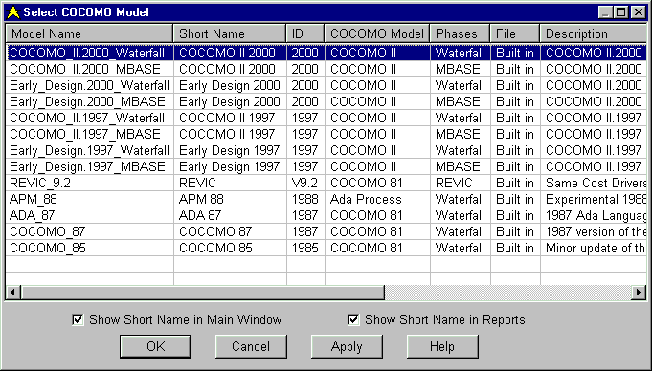
Figure 6 -- Select COCOMO Model Window

5. Learning About Costar & COCOMO

5.1 Online Help
Costar includes context-sensitive online Help and topics outlining the most important Costar tasks and concepts.

5.2 Costar Readme File
Costar's readme.txt file was installed in the same Folder as the executable program. You should read this file before using Costar.

5.3 COCOMO Books
Software Engineering Economics defined the original COCOMO model, and is still valuable. Software Cost Estimation with COCOMO II is the best source of information about COCOMO II.

5.4 COCOMO II Model Definition Manual
The COCOMO II Model Definition Model may be updated more often than the books. Check the websites http://www.SoftstarSystems.com and http://www/sunset.usc.edu.

5.5 Ada COCOMO & Incremental COCOMO
These papers define the Ada COCOMO and Incremental COCOMO models. Let us know if you'd like a copy of these papers:
- TRW IOC Ada COCOMO: Definitions and Refinements, Barry Boehm & Walker Royce, 1987 & 1988
- Ada COCOMO Refinements, Barry Boehm, 1988
- Recent Developments in Ada COCOMO, Barry Boehm, 1989
- Ada COCOMO and the Ada Process Model, Barry Boehm & Walker Royce, 1989

5.6 Softstar Systems Website
The Softstar Systems website (http://www.SoftstarSystems.com) includes background and tutorial information on the COCOMO II model.

The website also has a list of Frequently Asked Questions, and the latest news about COCOMO II and Costar.

The latest version of Calico, the calibration tool for COCOMO, is also posted here.

5.7 Support
Feel free to contact us with your Costar and COCOMO questions:
- E-mail: support@SoftstarSystems.com
- Fax: (603) 672-3460
- Phone: (603) 672-0987

5.8 Training
Costar is so easy to use that you probably won't need training in how to use the program. Check the page http://www.SoftstarSystems.com/training.htm for information about training in COCOMO II, Cost estimation, software project management, and related topics. Most of the training vendors have courses designed around Costar.

5.9 Costar Version Information
If you contact us for technical support, we'll probably need to know the exact version of Costar you're using. Use Help | About to display the version number, build number, serial number, etc.

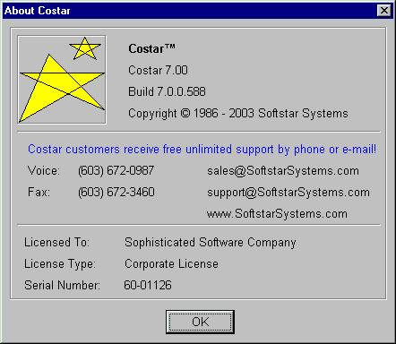
Figure 7 -- Help About Window

